**Ashwin Ramesh – Comp2007 Assignment 2**

**Algorithm Explanation:**

To calculate the disconnecting power of each node, all cut vertices must be established. At the same time, the number of nodes that make up each sub tree in the graph must also be calculated.

Once these two factors are known, to calculate the disconnecting power, all that must be done is to iterate through the nodes and establish the various new forests created and use the subtree sizes to calculate the eventuating D.P.

For example, if a cut vertex is removed and all that remains is 3 separate forests of size: 10, 2, 5. The D.P = 10x2 + 10x5 + 2x5 = 80

Detailed Algorithm:

Assume the graph and nodes has the following properties:

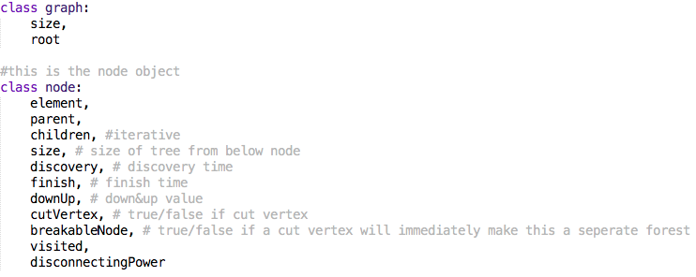

Depth First Search Algorithm:

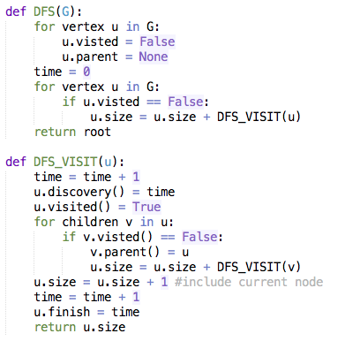

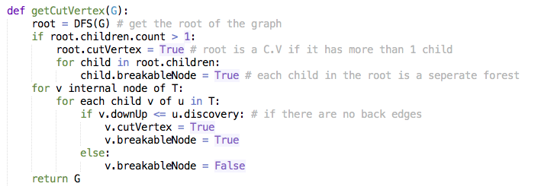

Cut Vertices Algorithm:

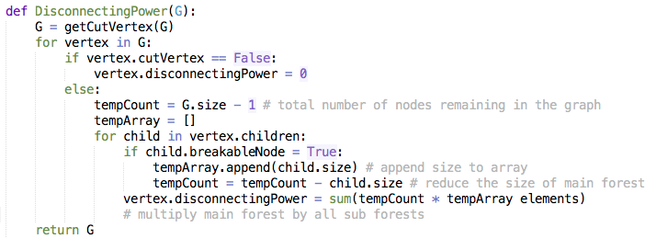Disconnecting Power Algorithm:

**Proof of Correctness:**

The main point to note is that if we remove a cut vertex, all nodes above and to the left and right are still connected, making a “major” forest.

This means that the only calculation required is to determine the size of all the smaller forests below and to take into account any back edges that will further increase the size of the “major” forest”

Once the size of the major forest is calculated and all the sizes of the smaller forests are also determined, it is only a matter of multiplying and summing up the results to get the final Disconnecting Power.

The root node is only a C.V. if it has more than 1 child. This is obvious because two or more sections/forests will be created.

Leaf nodes have no children thus they are never C.V.

Inner nodes, as mentioned above can be cut vertices only if there is a back node attributing from all children of the C.V. back above the C.V.

As long as these conditions are adhered by, the final result will always be correct.

**Time Complexity:**

Depth First Search: run in O(m) time as the graph is connected. (m = n i.e. O(2m) = O(m) )

Cut Verticies: Runs in O $(n^{2})$ time as the two for loops will iterate a maximum of n times. The DFS is added on, but O(m) < O $(n^{2})$, thus meaning O $\left(n^{2}\right)$ is the complexity

Disconnecting Power: Runs in O $(n^{2})$ also as the first for loop runs in O(n) time and the second will sum up to O(n) time. Adding the C.V. algorithm still ensures that this will run in O $(n^{2})$